**Applying CSS in ReactJS**

**1)Inline Styles:-**

* Inline css in the same line of an element.
* Here we are using style attribute apply the css.
* CSS property names in camelCase, and the values are the corresponding property values.

**App.jsx**

import React from 'react'

import { useState } from 'react'

const App = () => {

  let [info, setInfo] = useState(

    {

      name: "sai keerthana",

      age: 24,

      course:"JAVA FULL STACK"

    }

  )

  return (

    <>

      <section style={{background:"red",height:"300px",width:"200px",padding:"10px 30px"}}>

        <h1 style={{fontSize:"25px",fontWeight:"bolder"}}>Name : {info.name}</h1>

        <h2>Course: {info.course}</h2>

        <p>Age : {info.age}</p>

      </section>

    </>

  );

}

export default App

**2.Module CSS**

* If we want to apply css for particular set of components that is present in particular folder inside src.
* Here we have to create separate file for css
* Here CSS file name should have .module.css extension.

🡪filename.module.css

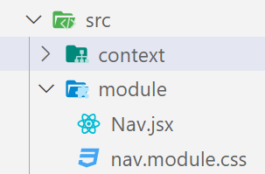

* After creating CSS file in which component, we want we have to import it.

Nav.jsx.

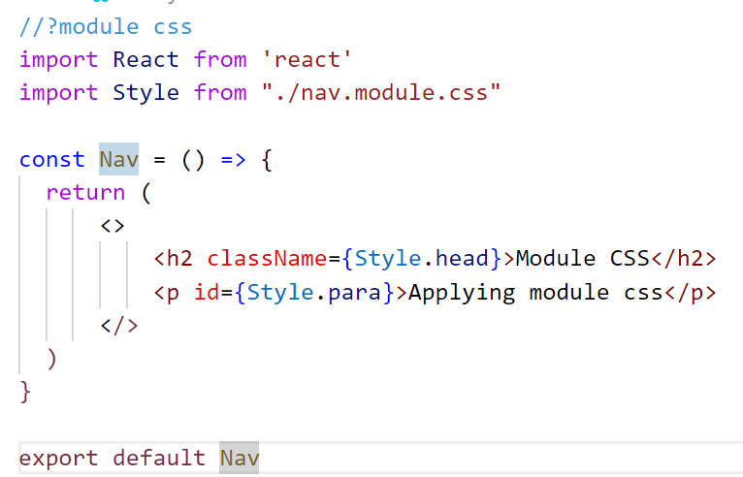

nav.module.css

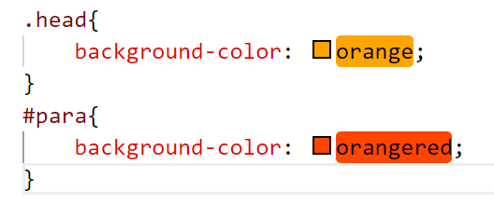

App.jsx

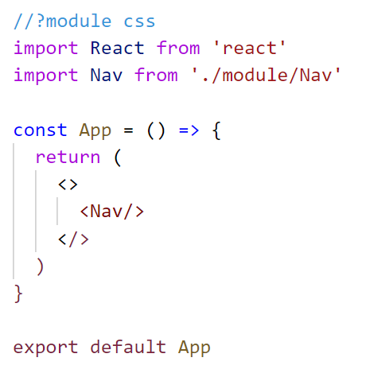

**3.Global CSS**

* Global css is used to apply css properties to anywhere with in the project for the components.
* Here we have to create separate file for css
* Here CSS file name should have .css extension.

🡪filename.css

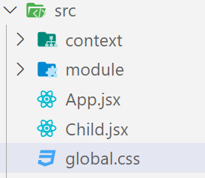

* After creating CSS file import it into entry file i.e index.js

Index.js

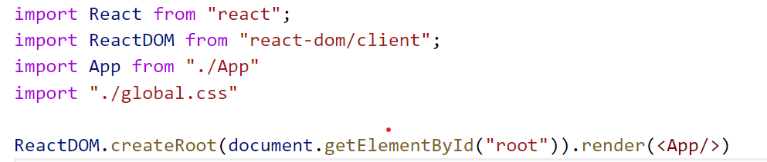

App.jsx

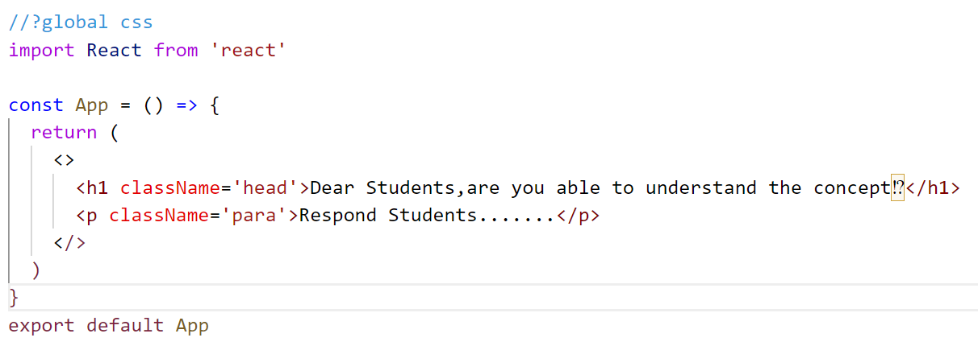

global.css

